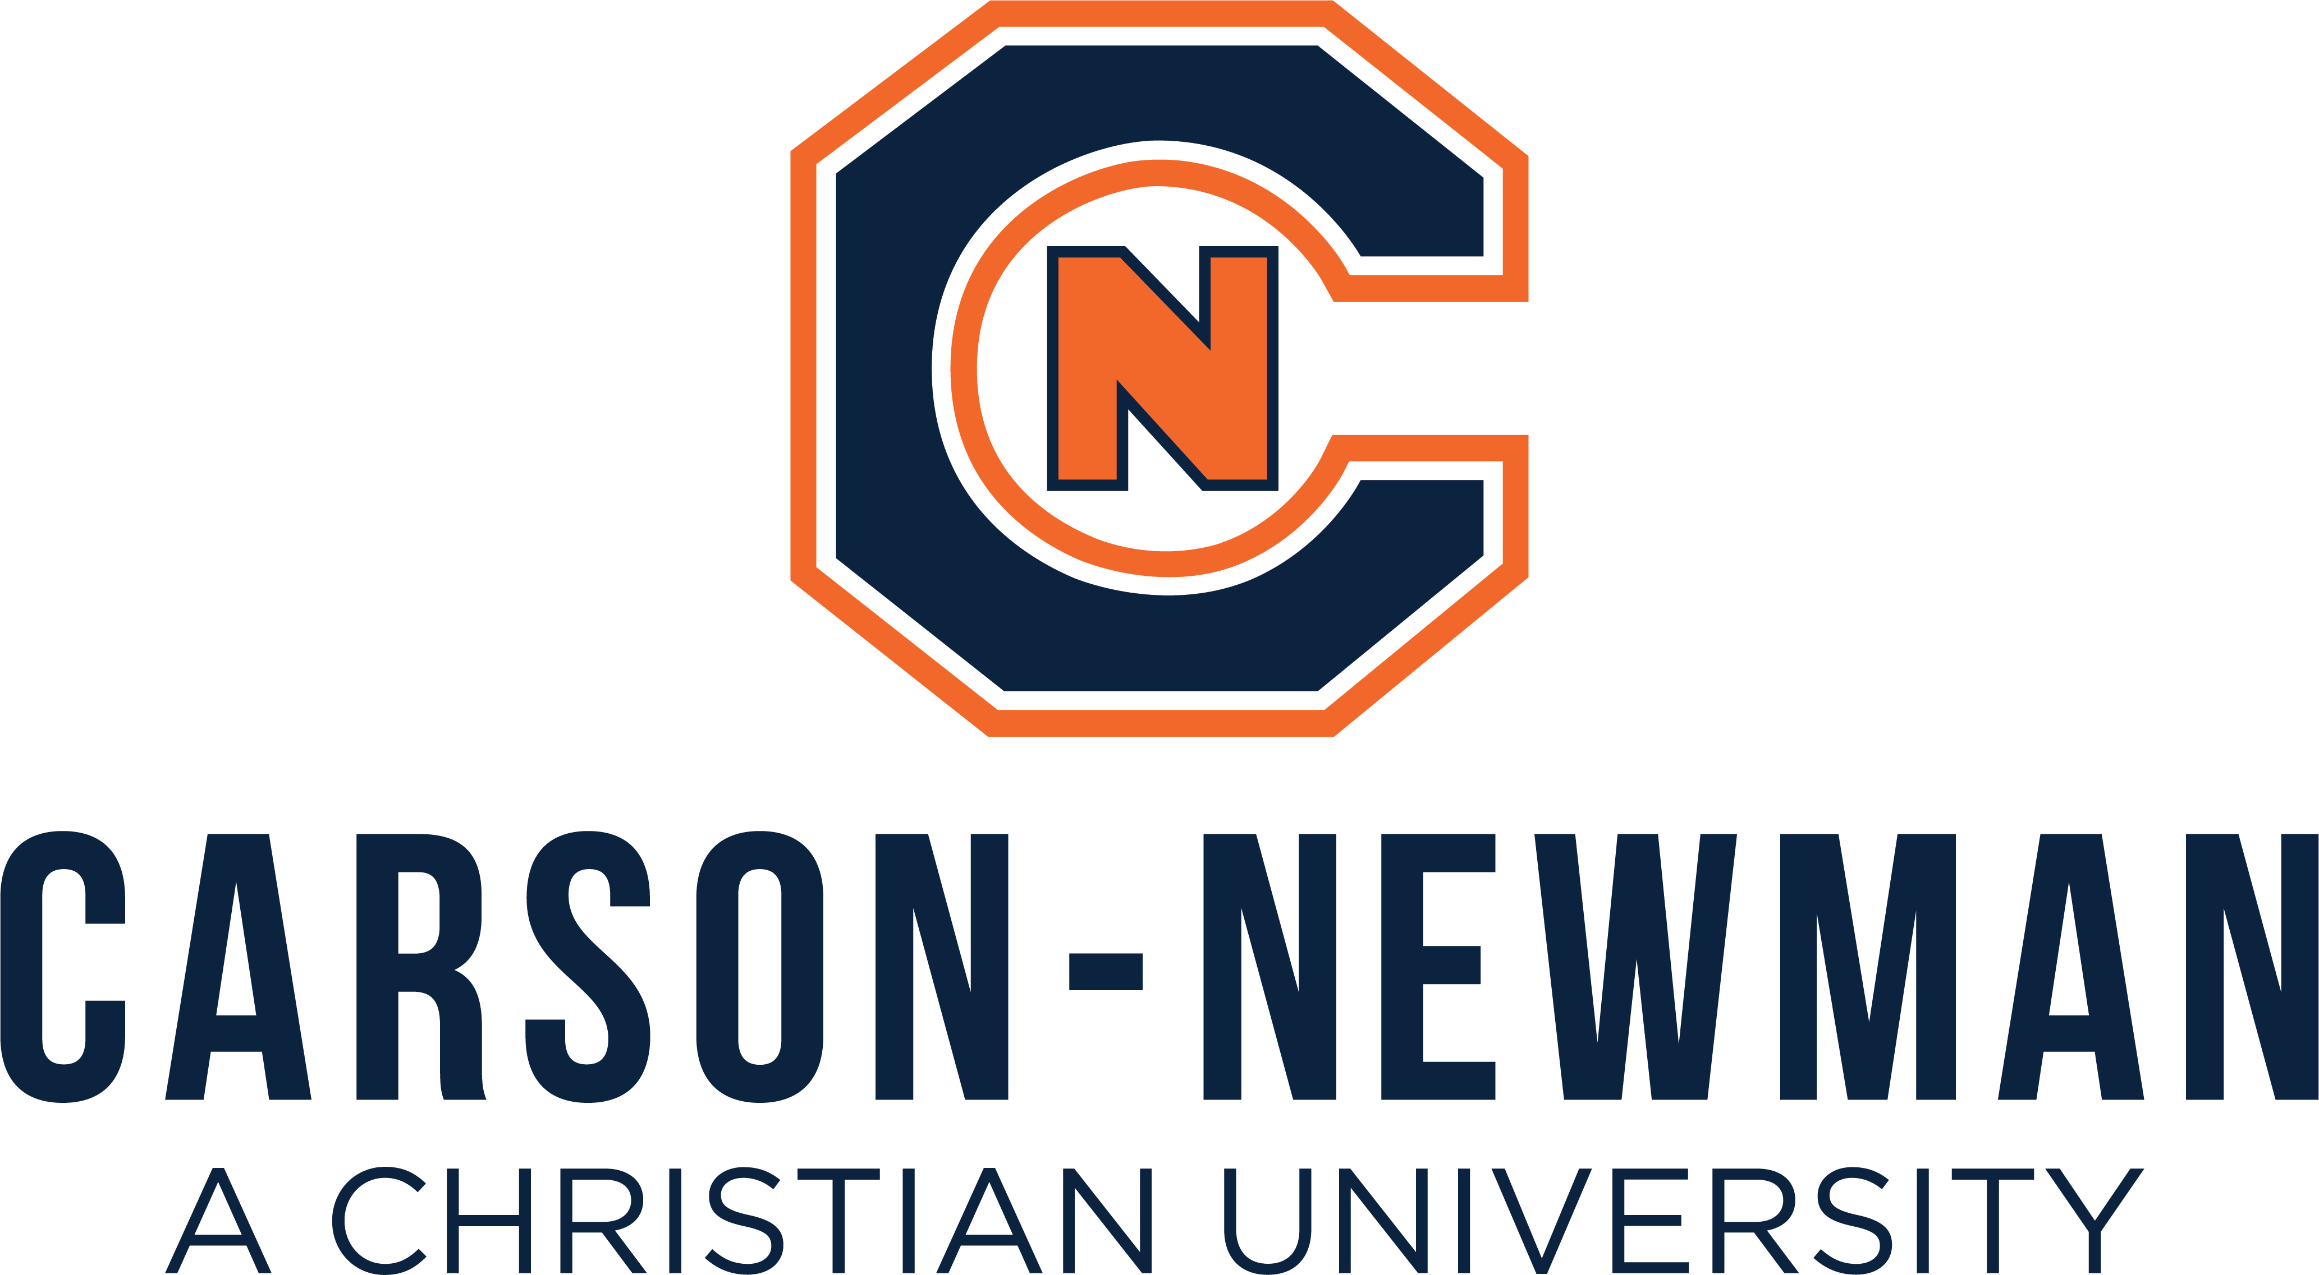

Dual Enrollment Agreement Form

We the undersigned acknowledge and agree that:

- As a Christian liberal arts institution, Carson-Newman University’s mission is to help our students reach their full potential as educated citizens and worldwide servant-leaders.
- The courses attempted at Carson-Newman and grades obtained are permanent records on the student’s university transcript and establish their permanent college GPA.
- The courses offered by Carson-Newman University are designed to be taken by students aged 18 or above and are thus taught at a collegiate level, meaning that Dual Enrolled students are held to the same academic standards in their courses as traditional college students. Carson-Newman catalog policies concerning refund and withdrawal dates apply to Dual Enrollment students.
- Students may take up to a maximum of 11 hours of Dual Enrollment courses in a given semester at the Dual Enrollment tuition rate of $166 per credit hour with a $10 per credit hour technology fee. Additional expenses, such as books must be covered by the student and their family.
- The student and/or the parent/guardian is responsible for paying the remaining balance for tuition and fees not covered by the Dual Enrollment Grant or other applicable aid to the university on or before the first day of each academic term.
- The Carson-Newman University Office of the Registrar has permission to mail or otherwise transmit a copy of the student’s transcript to the high school counselor at the end of each academic term of Carson-Newman dual enrollment. The Registrar and Dual Enrollment staff have the right to discuss any academic progress or other issues regarding a Dual Enrollment student with a high school counselor, or administrator, or parent.
- The University staff and faculty may communicate information about the student’s grades, academic progress, needed actions, and other information to the student, the student’s family, and appropriate high school officials.
- This document serves as the high school counselor recommendation/approval for the herein-named student to participate in C-N dual enrollment.

Dual Enrollment Student Name (Please Print): ______________________________________________

___________________________________________________________ _________________
Signature of Student Date

Parent/Guardian Name (Please Print): ______________________________________________________

___________________________________________________________ ___________________
Parent/Guardian Signature Date

Please list the courses you plan to take as a Dual Enrollment Student at Carson-Newman:

Name of School Counselor (please print): ___________________________________________________

_________________________________________________________ ___________________
Signature of School Counselor Date

Name of High School/Homeschool Affiliate: __________________________________________________________

