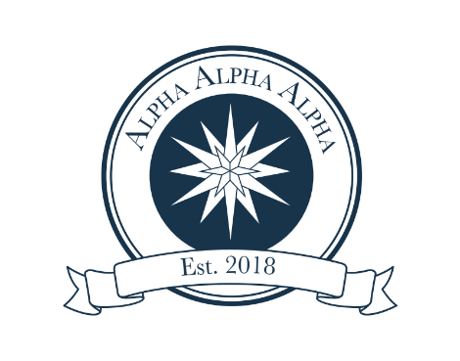
Student Application

________________________________________________________

First and last name (as it should appear on the certificate of induction)

________________________________________________________
Student ID #

________________________________________________________

________________________________________________________
Current home mailing address

________________________________________________________
Best contact phone number for you

_________________________________________________________
Email address

Make check out for $15 to Carson-Newman University by March 1, 2023. Write “Tri-Alpha” in the memo area. Cash is also accepted; sorry, no credit cards. Bring check or cash to Annemarie Spain in the Student Success Center, located on the 2nd floor of the Stephen-Burnett Library in #210.

If you would like to purchase a cord to wear at graduation and/or the induction ceremony, please include an additional $20.

Please call Annemarie Spain at (865)471-3483 or e-mail at aspain@cn.edu with any questions.

