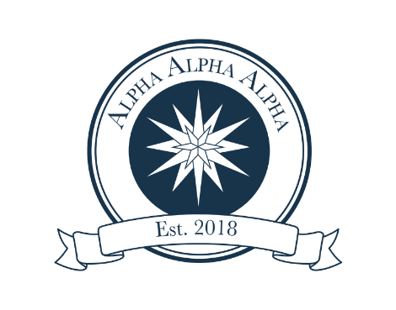
Faculty/ Staff Application

______________________________________________

First and last name (as it should appear on the certificate of induction)

________________________________________________________

________________________________________________________

Degree/s Earned and name/s of Institution

______________________________________________

______________________________________________
Current home mailing address

______________________________________________
Best contact phone number for you

______________________________________________
Email address

_$________

If you would be willing to sponsor a student/students of limited means for Tri-Alpha, please indicate amount above.

Make check out for $25 to Carson-Newman University. Write “Tri-Alpha” in the memo area. Cash is also accepted; sorry, no credit cards. Bring check or cash to Annemarie Spain in the Student Success Center, located on the 2nd floor of the Stephen-Burnett Library in #210. If you would like to purchase a cord, the cost is an additional $20.

Please call Annemarie Spain at (865)471-3483 or e-mail at aspain@cn.edu with any questions.

