Revised
1/14/2021
Financial Aid Handbook
Terms & Conditions of Your Awards
Financial Aid Office
Butler Hall Welcome Center
1645 Russell Avenue
Jefferson City, TN 37760

financialaid@cn.edu

Table of Contents

Mission Statement 3
Objectives 3
Non-Discrimination Policy 3
General Aid Provisions 4
Student Rights & Responsibilities 5
University Gift Aid Cap Policy 6
Disbursements 7
Credit Balance Refund Checks 7
Cost & Estimated Net Price Cost Calculator 7
Payment of your Account 9
Initial Eligibility & FA Satisfactory Academic Progress (FASAP) 9
Qualitative FASAP 10
Quantitative FASAP 10
Maximum Timeframe 10
Zero Term GPA (0.00) 10
FASAP Evaluation Process 10
FASAP Process Illustration 12
Change in Enrolled Hours 12
Change in On-Campus Status 12
Verification Process 13
Student Disclosure Family Educational Rights and Privacy Act (FERPA) 14
Your C-N E-Mail Account 14
Your C-N Connect Account 14
E-Consent 16
Accept or Reject Your Financial Aid Awards through C-N Connect with MYCN Financial Aid Access 17
Accept or Reject Your Financial Aid Awards on Paper 18
Revisions to Your Financial Aid 18
Carson-Newman University Aid Continued Eligibility Criteria 19
Federal Pell Grant 20
Federal SEOG Grant (FSEOG) 20
Teacher Education Assistance for College and Higher Education Grant (TEACH) 20
TSAA Grant 21
Tennessee Education Lottery Scholarships (HOPE) 21
HOPE Scholarship – Summer 21
Continuous Enrollment 21
Change in Enrollment 22
Benchmark 22
Requirements for Continued TELS (HOPE) Eligibility 22
How to Calculate your TELS HOPE GPA 22
Loss of HOPE & Appeal Process 23
120 Hour Limitation 23
Outside Aid 23
Student Employment- Federal Work-Study (FWS) 24
Federal Direct Stafford Loans 24
Loan Limits 25
Interest Rates 26
First-Time Borrowers 26
Continuing/Previous Borrowers 27
Federal Direct Parent Loan for Undergraduate Students (PLUS) 27
Direct Federal Grad PLUS Loans 28
Private Loans 28
Comparison of Federal Loans versus Private Loans 29
Adjustments and Appeals 30
Financial Aid Appeal 30
FASAP Appeals 30
TELS HOPE Appeals 31
Where to Mail Appeals: 31
Withdrawal from Carson-Newman 31
Official Withdrawal 31
Last Date of Attendance 31
Unofficial Withdrawal determinations for Administrative Withdrawal Actions: 31
Loan Exit Counseling Required 31
Remaining Balances After Withdrawal 32
Tuition Refund Schedule for Withdrawal from Fall and Spring Standard Terms*: 32
Financial Aid Office Contact Information 33
Glossary of Financial Aid Acronyms 34

Mission Statement

Our mission is to serve students fairly with the resources they are eligible to receive in order to accomplish their goals and fulfill their dreams.

Objectives

The Financial Aid Office has developed a philosophy of awarding aid to accomplish several objectives given the limited resources available. These objectives are as follows:
- To meet the needs of as many eligible students as possible
- To consider primary responsibility for meeting education costs rests with students and parents
- To award grants and scholarships to the maximum extent possible before self-help aid such as loans and student employment

Non-Discrimination Policy

Carson-Newman University does not unlawfully discriminate on the basis of race, color, sex, national origin, disability, age, veteran status, or genetic information in provision of its education policies, programs, services and activities or employment opportunities and benefits.

The University does not unlawfully discriminate on the basis of race, sex or disability in its education programs and activities pursuant to the requirements of Title VI of the Civil Rights Act of 1964, Title IX of the Education Amendments of 1972, Section 504 of the Rehabilitation Act of 1973, and the American with Disabilities Act (ADA) of 1990.

Inquiries and/or charges of violation concerning Title VI, section 504, ADA, the Age Discrimination in Employment Act (ADEA) or any other of the other referenced policies should be directed to the Director of Human Resources, 1646 Russell Avenue, Suite 204 Fite Building, Jefferson City, Tennessee. 37760, telephone 865-471-7164.

The University is required by Title IX of the Education Amendments Act of 1972 and its implementing regulation at 34 C.F.R. Part 106 not to discriminate unlawfully on the basis of sex in its education program or activity. This prohibition extends to employment and admission. Inquiries about the application of Title IX may be directed to the Title IX Coordinator, Shelley Ball, Assistant Vice President for Student Services, 2130 Branner Avenue, Maddox Student Activities Center, Office # 2009-C; telephone 865-471-3238; sball@cn.edu and/or to the Assistant Secretary of Education for Civil Rights, U.S. Department of Education.

Carson-Newman University does not discriminate on the basis of race, color, gender, national origin, disability, age, veteran status, or genetic information in provision of its policies, programs, services, and activities.

General Aid Provisions

The following are basic eligibility guidelines:
- To renew your federal, state, or need-based C-N aid, you must file the Free Application for Federal Student Aid (FAFSA) after October 1 of each year. Priority FAFSA deadline is February 1st of each year.
- Your award is based on your financial information supplied by you and/or your family. Your award is subject to revision if your financial situation changes, errors in data are discovered, you decide to live off campus, you drop below full-time enrollment, or additional assistance from other sources exceeds your individual limits.
- Your award is determined in accordance with laws, regulations, and appropriations (existing or anticipated) of the U.S. Department of Education and by the regulations of the applicable federal, state, and University programs. Award provisions are subject to change without notice.
- Your financial aid student records are protected under the Family Educational Rights and Privacy Act of 1974 (FERPA). For more information, contact the Financial Aid office.
- By signing your Financial Aid Offer or by accepting your aid through C-N Connect, you are authorizing us to release information to the U.S. Department of Education, state agencies, scholarship donors, scholarship selection committees, and other C-N departments as needed for processing your financial aid awards.
- You are required to notify the Office of Financial Aid in writing or via email of the amounts of any financial aid received from outside sources and of any changes in enrollment status.
- Carson-Newman University aid is available for 8 semesters for incoming traditional freshman. Traditional transfer students may retain this award for the number of semesters normally required to achieve graduation.
- In preparing undergraduate financial aid offers, we assume full-time enrollment each semester. Undergraduate students must contact the office of Financial Aid if you will enroll for less than full-time attendance or if you plan to repeat a course in which you have earned credit previously. To reflect your current status, the Financial Aid Office will adjust awards after each drop period ends. Due to C-N policy of grade replacement when repeating a course with a D or better, your financial aid enrollment status will be based on courses for which you will receive new credit. For examples of how this policy is applied, review the SAP section of this document.
- C-N University aid is reserved for full-time traditional day students seeking their first undergraduate degree.
- You must be enrolled at least half-time to maintain eligibility for loan disbursements each semester. Undergraduate and graduate enrollment of at least half-time is 6 credit hours per term.
You will be notified by the Financial Aid Office either by email or postal mail of changes to your federal financial assistance. You must have a valid C-N email address. It is your responsibility to check your mail and/or your C-N email account for notification of changes.

Student Rights & Responsibilities

In accepting a financial aid award from Carson-Newman University, you acknowledge certain rights and responsibilities. This information was provided to you in your initial financial offer documents and emails and is also available on the financial aid website.
As a student financial aid recipient, you have the right to:
- Know the correct deadlines for submission of applications for aid and procedures to be followed.
- Know the types of aid available including all federal, state, and University aid programs and what policies or regulations govern these programs.
- Know the cost of attendance at Carson-Newman and the University’s refund policy
- Know how financial need is determined, what the criteria are for awarding aid, how academic progress is determined, and what you must do to continue receiving aid.
- Know the type and amount of aid you will receive, how much of your need has been met, and how and when you will receive your aid funds.
- View the contents of your student financial aid file in accordance with the Family Educational rights and Privacy Act (FERPA).
- Know the conditions of any loan you accept.
- Know the terms, conditions, and pay rate for any student job you accept under the Federal Work Study Program.
- You have the right to an appeal for decisions denying you financial aid. Appeals must be filed no later than 30 days from the decision of denial.
- Expect and receive complete confidentiality about financial aid awarded by our office.
As a student financial aid recipient, you have the responsibility to:
- Accurately complete and submit application materials within required or recommended time frames and know and comply with enrollment requirements related to financial aid eligibility.
- Read all materials sent to you in paper or electronically from the Financial Aid Office and other agencies awarding you aid. Read, understand, and keep copies of all forms you sign, and check your C-N email often.
- Accept responsibility for all agreements and forms you sign on paper or electronically.
- Use funds awarded to you solely for educational expenses incurred while attending Carson-Newman.
- Notify the Financial Aid Office when you change housing or enrollment status.
- Know and comply with the rules governing the aid you receive to include the Satisfactory Academic Progress Standards.
- Provide additional documentation, federal tax transcripts, W-2's, and any additional information when requested by the Financial Aid Office.
- Comply with the provisions of any billing promissory note and all other University agreements you sign and know the University's refund policy and implications that dropping a course or withdrawing from the University will have on your student financial aid eligibility.
- Repay all educational loans according to the repayment provisions agreed upon at the time the loan was accepted and the promissory note signed.
- Students borrowing Federal Direct Loans are required to enroll at least half-time and will be required to complete exit counseling upon ceasing enrollment.
- Report any wages, loans, grants, or scholarships received from external private sources to the Treasurer’s Office / Student Accounts Office. External sources of aid may cause a revision of aid awarded to you.
- Keep your local and permanent addresses current with the Registrar’s Office and with any lending institutions.

University Gift Aid Cap Policy

University aid is considered the last gift dollars applied to the student charges, and the University reserves the right to reduce, modify, or cancel awards when aid limits are exceeded, and/or the University determines at any time you are no longer eligible for the assistance. No cash credit balance refunds will be generated from University funds as the last resource.

Disbursements

All financial aid will be credited to your student account each term, provided we are not missing any required forms or documents. Students that have been selected for verification of FAFSA information must complete the process before aid may be disbursed. Refer to the verification section for more information. For traditional semester attendance, disbursement is scheduled three weeks after the start of the term, upon confirming you have begun attendance in each class anticipated. Until the aid is disbursed to your student account, aid will be pending. Award amounts will be based upon your actual attendance in each class. For instance, if you register for 12 credit hours, but only begin attendance in 9 credit hours, your award amounts will be re-calculated for 9 credit hours. It is important to begin attendance and have your schedule finalized by the last day to make a schedule change without a fee (Census date) each term.
Disbursement dates for module classes will be scheduled within 24 hours of each census date during each module of anticipated enrollment.

Credit Balance Refund Checks

After disbursement of aid, you may qualify for a credit balance refund check. The Treasurer’s Office/Student Accounts Office will notify you by email that your check is available for pick up. The University has fourteen days to issue a credit balance refund check created after disbursement of federal aid. Questions regarding check availability should be directed to Student Accounts.

Cost & Estimated Net Price Cost Calculator

Estimated Undergraduate Budget for 2020-2021
Full-Time, Traditional Enrollment
Estimated Direct (billable) Costs 2020-21
Tuition & Fees: $29,500
On-Campus Room and Meals: $8,894
This is an estimate of what a student will spend on housing and meals for the Fall and Spring semesters and will vary depending on the actual housing and meal options selected.
Total Estimated Direct (billable) costs: $38,394
Estimated Indirect (nonbillable) Costs 2020-21
Books: $1,600
This is an estimate of what a student will spend on books for the Fall and Spring semesters.
Transportation: $1,276
This is an estimate for budgeting purposes only and will not be billed to you.
Personal & Miscellaneous: $1,890
This is an estimate for budgeting purposes only and will not be billed to you.
Estimated Grand Total: $43,160

*Your residence hall will vary in cost. The above cost is an average for planning purposes and includes Appalachian Commons in the average.
**Smaller meal plans are available for returning students, but freshmen are required to purchase the unlimited plan when living in a residence hall.
- Indirect costs are costs that you may or may not incur and are only estimates. Your actual indirect cost may be lower or higher.
- Cost of Attendance (COA) includes both direct indirect costs. Your financial need is based upon your COA. (COA-EFC=NEED)
Any undergraduate traditional student whose credit hours are below 12 credit hours per semester will be charged a per credit hour rate. Any hours above 17 credit hours per semester will incur a per credit hour charge in addition to the full-tuition rate. In addition, there may be extra fees for certain programs, such as Music and Nursing, and there are additional fees for on-line course work. For specific fee information, please contact Treasurer’s Office/Student Accounts Office or refer to catalog.
++ Do not include work-study if you plan to use those funds for other costs besides your bill with Carson-Newman. Work-study award does not guarantee that a student will earn the entire award amount or have a job placement.

Payment of your Account

Students who register for courses incur tuition charges. You, the student, will be responsible for payment of tuition charges for course registration unless the Registrar’s Office is notified by you to cancel your course registration prior to the day classes begin.
Tuition, fees, and all other costs for the semester are payable upon registration. If you have Financial Aid funds, the difference between the total cost for the semester and the financial aid commitment is payable upon registration. Payment of the difference between enrollment charges and financial aid may be made by cash, personal check, DISCOVERCARD, VISACARD, MASTERCARD, or through the TuitionPay monthly payment plan. Information on this plan is mailed to you by the Treasurer’s Office each summer or available at payplan.officialpayments.com.
Finance charges will be assessed on your unpaid balance 30 days after the start of the semester at the rate of 18% per year. You must make every effort to have all paperwork completed with the Office of Financial Aid to ensure that all anticipated financial aid will be credited to your account prior to the day that finance charges are assessed.
By enrolling, you agree to pay all expenses incurred by Carson-Newman to collect any outstanding debt, including attorney and collection agency fees. Carson-Newman reserves the right to report the status of any outstanding indebtedness owed to credit reporting agencies.
You must settle your account for the current semester, including library and traffic fines, infirmary charges, etc., before you will be eligible to enroll for a subsequent semester or before a transcript of your academic record can be released by the Registrar’s Office.
If you have questions about the billing statements or payment of your student account, please contact the Treasurer’s Office/Student Accounts at 865-471-3209, P.O. Box 557, Jefferson City, TN 37760 or Student-Accounts@cn.edu.

Initial Eligibility & FA Satisfactory Academic Progress (FASAP)

Initially, to be eligible to receive financial assistance, you must be admitted into an eligible program. Financial assistance is considered renewable up to 150% of the approved program of study, provided you satisfy the standards of FA Satisfactory Academic Progress (FASAP) as outlined below.
You will be considered as making satisfactory progress in receiving financial assistance if you are making progress at a rate not less than demonstrated by the following qualitative and quantitative scales:

Qualitative FASAP
- Degree Type | - Number of Cumulative Credit Hours Attempted | - Minimum Cumulative GPA Required
Bachelors | 1-30 | 1.50
 | 31-45 | 1.70
 | 46-59 | 1.90
 | 60+ | 2.00
Masters | 1+ | 3.0

Quantitative FASAP
In addition to the above, you must earn 67% of Attempted Credit Hours to qualify, as listed below:
- Attempted Credit Hours | - Minimum Credit Hours to Earn (67%)
30 | 20
24 | 16
12 | 8
9 | 6
6 or less | 4

Maximum Timeframe
- Type of Degree | - Number of Required Credits for Degree | - Maximum Cumulative Attempted Credits (150%)
Bachelors | 120 | 180
Masters- Consult catalog for specific degree requirements | 33+ | 150%

Zero Term GPA (0.00)
If you earn a 0.0 GPA in a term, the Registrar will determine if you completed and earned all F’s in your classes. If the Registrar determines that you stopped attending every class, you will be processed by the Financial Aid Office as an unofficial withdrawal.

FASAP Evaluation Process
- REVIEW Each Term: Review for SAP will be conducted at the conclusion of each term, including summer. Students who are determined to be ineligible for further aid will be notified. It is your responsibility to ensure that lost eligibility is restored.
- WARNING Status: Students will have one semester of WARNING on the first instance of a failed FASAP calculation. Warning notice will be sent to CN email account if e-consent is on file.
- UNSATISFACTORY Status: A subsequent calculation failing FASAP will result in Financial Assistance UNSATISFACTORY standing (suspension), and students will be ineligible for financial assistance without a successful appeal. Unsatisfactory notice will be sent to your CN email account if e-consent is on file.
- APPEALS FASAP: Students may appeal an unsatisfactory status for FASAP calculation. Appeals must be made to the Financial Aid Office by the deadline given in each notification. (Forms)
- PROBATION Status: Students that filed a successful appeal from an unsatisfactory status will be granted a one term of probation in which they will be eligible for financial aid. After the probation term, students must meet the standards satisfactorily to continue aid eligibility.
- W, F, or I Grades: All grades of F, W, WP, WF, U, or I will not count as hours earned but will count as hours attempted.
- REPEATED Hours: Repeated hours will count towards attempted hours but may not be countable in enrollment status for the term depending upon number of times they are repeated for a grade. For example, if you earned 3 hours with a grade of “D” twice, and you decide to repeat the course to earn a better grade, the repeated 3 hours will not count in your enrollment status for the term that it is a second repeat. Hence, your enrollment status for the term will be calculated as: registered credit hours– second or more repeated credit hours= enrollment status for federal financial aid purposes. This is subject to change as Federal Regulations are subject to change. All attempted hours will count against your 150% of degree credits limitation.
- TRANSFER Credits: Transfer credits accepted by Carson-Newman University for credit will count in attempted and in total earned hours.
- TELS HOPE Awards: Evaluation to determine continued eligibility for TELS HOPE awards will occur upon attempting 24, 48, 72, 96, and 120 hours for coursework completed after high school graduation and is a separate process than FASAP calculations. If you fail to meet TELS SAP, you will be sent a written letter with important information, and future TELS awards may not be available to you. Click HERE for more information regarding TELS HOPE continuation requirements. Your TELS HOPE GPA is not calculated the same as your CN GPA calculation.
- APPEALS TELS HOPE Loss: Students may appeal TELS HOPE loss on reasons other than GPA.

FASAP Process Illustration
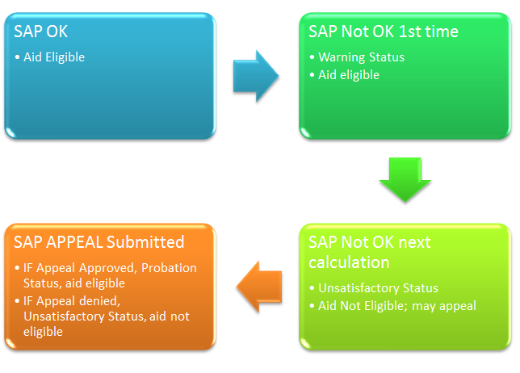

Change in Enrolled Hours

You must consult with the Financial Aid Office before dropping hours in order to determine the effect on financial assistance eligibility. Undergraduate University assistance is only available to full-time undergraduate students enrolled in our traditional program. A change in the number of hours enrolled may result in a reduction of financial assistance. It is the student’s responsibility to notify the Financial Aid Office of changes in enrollment status prior to the end of the drop period. At the end of the drop period, students who are below full-time enrollment will have their aid reviewed to confirm eligibility prior to any credit balance refunds being processed. Hope recipients must stay at the same level of hours as of the census date or they may forfeit the Hope Scholarship in the current and future semesters.

Change in On-Campus Status

Students should consult with the Financial Aid Office before moving off campus in order to determine the effect on financial aid eligibility. A change in status requires the file to be reviewed for eligibility for University aid and other aid, as the cost of attendance is lower for off-campus and with-parents living. An audit will be conducted after the census date each term to find any required revisions of students that are living off campus.

Verification Process

Not all students will be selected for the verification process. The verification process is used to confirm certain information you provided on your FAFSA. Some students are selected by the U.S. Department of Education randomly or because FAFSA data was incomplete, estimated, or inconsistent; others may be selected by our office based on conflicting information.
If you are selected for verification, Carson-Newman is required to collect documentation from you to confirm or correct the information reported on your FAFSA. If selected, you will receive a letter detailing the documentation needed from you to complete the process. The verification process ensures that eligible students receive all the aid for which they qualify.
Regardless of why you were chosen, our office will work with you to collect the proper documentation. Carson-Newman may issue you a financial aid offer with tentative aid, but we will not be able to apply aid to your student account until verification is complete. Please understand that your financial aid is subject to change as a result of verification.
Not all students will need the same documentation, so pay special attention to any letter we send you. Please do not send documents unless requested. Generally, however, you will need at least the following:
- Signed Verification Worksheet (Dependent Student OR Independent Student)
- Copies of IRS Tax Return Transcript(s) (Note: if you used the IRS Data Retrieval option when completing the FAFSA and have made no changes to the tax information, a tax return transcript may not be required).
- Copies of W-2s
It is important that all documents requested be returned to our office as quickly as possible to avoid delays. If you have amended your tax return(s), we will need a transcript of the amended version. If you have requested an extension for filing your return(s), please send a copy of the extension until you are able to provide the completed transcript.
Completing this process as soon as possible cannot be overstressed. We want to be able to give you accurate financial aid, rather than tentative aid that is subject to change. Please understand that all information will be kept confidential in our office. Once your file has been reviewed, it may be necessary to correct your FAFSA information. If we correct information while you are in verification, please do not correct your FAFSA back to what you originally filed, as this will create further delays. Suggested deadlines to submit information are below:
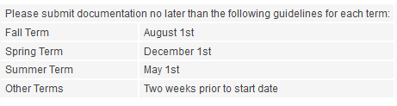
All documents and forms may be mailed, emailed or faxed to the Office of Financial Aid. Our contact information is at the end of this handbook.

Student Disclosure Family Educational Rights and Privacy Act (FERPA)

Students may authorize C-N to discuss their account information to third parties, but not all financial aid information may be discussed with third parties without the student present/on the phone with the third party to whom they have given authorization. We must have the permission in writing via the Disclosure Form on the Registrar’s Office website. The disclosure will remain in force until you, the student, revoke it. You should share the disclosure code with anyone that you authorize to have access to your information listed on your Disclosure Form. In rare instances, if the Financial Aid Office is able to determine dependency status, we may disclose financial information to your parent(s) without prior approval if they are listed on the FAFSA, we have a Tax Transcript to verify you are a dependent of your parent, and we verify the identity of the parent with the social security number on the FAFSA. For a Disclosure Form, visit the Registrar’s website.

Your C-N E-Mail Account

As a student, it is very important that you check your student e-mail daily. All correspondence from University offices will be sent to this e-mail address, and professors often use this e-mail to notify you about class information. Your student e-mail may be accessed through the link at the top of the C-N website, the C-N Connect Link, or through the Current Student Tab on the website:

Your C-N Connect Account

Information regarding your financial aid and billing is available through your C-N Connect Account. You will find C-N Connect by clicking on Current Students on the main page of the C-N website.
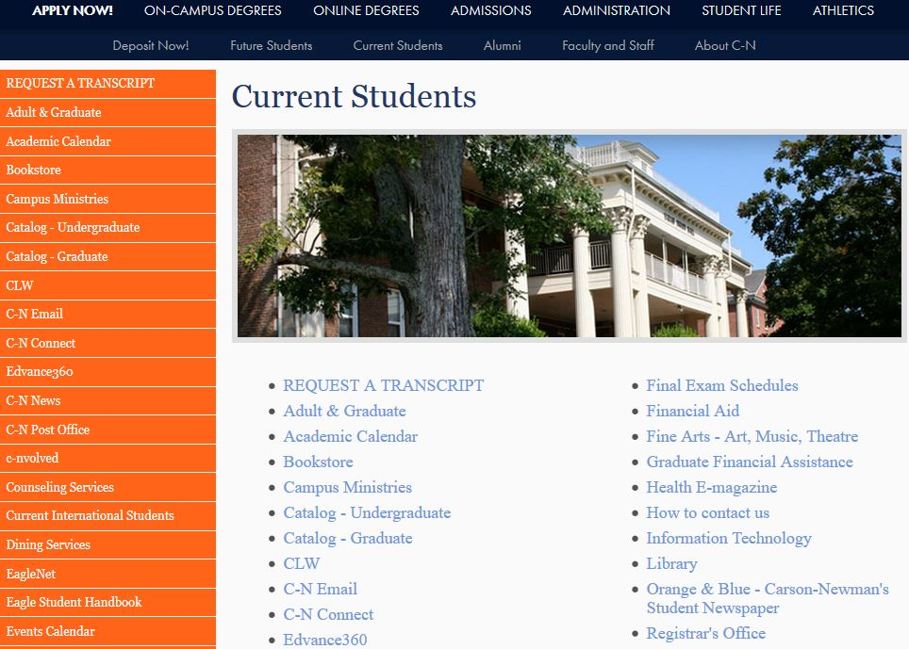
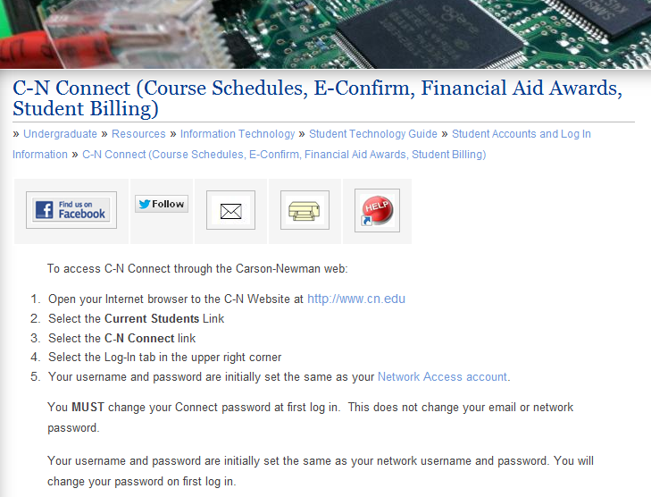

E-Consent

The first time you log in, you must e-Consent before your financial information will be displayed.
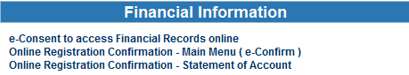
Granting e-consent, allows you to...
Have full access to the following electronic information and online processes:
  - Student Accounts and Financial Aid sections of C-N Connect.
  - Financial Aid Awards - includes the ability to accept or reject your awards online.
  - Student Account billing information, including disbursements, refunds, and paying your account online.
  - Promissory note completion and loan processing requirements.
  - Document Information - indicates documents received or missing.
Receive the following notices to your C-N email account:
  - Electronic Loan Disbursements- includes the amount, date of disbursement, and the right to cancel the loan within 14 days of the notice.
  - Reminder Notices- includes specific communication about your file directly to you if something is incomplete and about upcoming deadlines regarding your finances or paperwork.
  - Scholarship Opportunities- includes eligibility information and where to obtain an application.
  - Entrance & Exit Requirements- includes requirements for loans and/or TEACH Grants.
  - Credit Balance Refund Availability- includes when and where to obtain a check.
  - Document Information- includes missing information or information received.
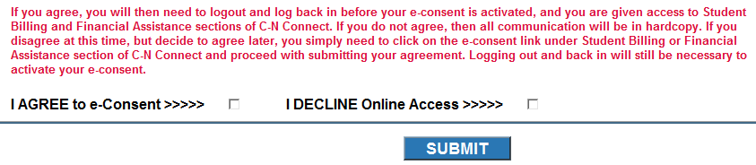
If you AGREE to e-Consent, you must log out and back in for the e-consent to be effective and show all your financial information. Upon completion of e-consent, you should see the following menu options:

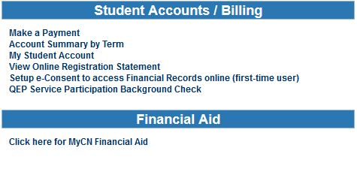

Accept or Reject Your Financial Aid Awards through C-N Connect with MYCN Financial Aid Access

There are web demonstrations to assist you with accessing information:
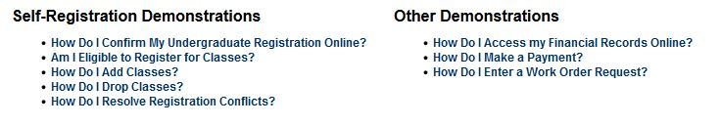
To accept or reject your awards, you will need to select the following:
This link will take you to the Financial Aid website where you may conduct all your financial aid business and keep up with your financial aid checklist. You need to make sure that you are in the correct award year so that you are viewing the correct and current information.
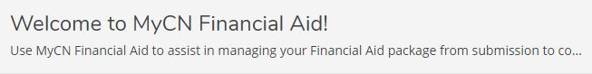
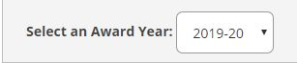
You will also see the following screen that is your Financial Aid Checklist. You will need to select the appropriate action to take, such as “Review and accept your Financial Aid Award Package.”
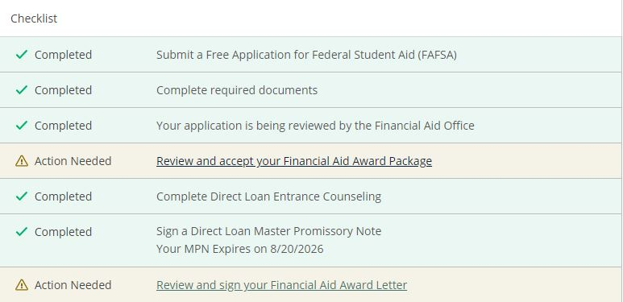
Once you click on that link, you will be taken to a page that lists all your financial aid. You will need to accept or reject each item, or you may accept or decline all at the bottom of your page. Once you complete this, you will be directed to electronically sign your Financial Aid Offer.

Accept or Reject Your Financial Aid Awards on Paper

As an incoming freshman, you will need to circle the A or R to accept or reject each award on the paper Financial Aid Offer. Then sign, date, and return one copy to the Office of Financial Aid, 1645 Russell Avenue, Jefferson City, TN 37760. Signed fax or email copies are also acceptable. Fax number (865) 471-2035 or by email financialaid@cn.edu.
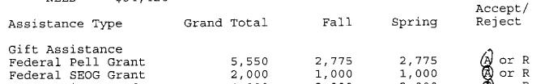

Revisions to Your Financial Aid

If a change to your aid occurs, you will be sent a Revised Aid Notification. If you receive a Revised Aid Notification, something has changed. You may receive this notice electronically to your C-N email account or in paper depending upon your e-consent status and access to C-N Connect account. Typically, revisions include (but are not limited to) the following:
- Federal FAFSA results are received that changes your eligibility for assistance previously awarded. Changes may be increases or decreases.
- Additional scholarship information is received that changes your eligibility. Changes may be increases or decreases.
- Different housing than was anticipated with your original award determination. Your Cost of Attendance (COA) will be adjusted to reflect the changes. This may affect previously awarded assistance.
- Changes in your credit load that result in part-time attendance. Generally, awards are offered assuming full-time attendance. Only full-time attendance in our traditional undergraduate program qualifies to receive University funded aid.

Carson-Newman University Aid Continued Eligibility Criteria

In order to remain eligible for your University aid, you must be enrolled as a full-time day student (FT) seeking your first bachelor’s degree, meet Satisfactory Academic Progress (SAP), and not be in default of any Federal Student Loan or overpayment of a federal grant. C-N grants are awarded at different amounts depending on the student’s on or off campus status, are considered LAST DOLLARS awarded before all other University gift aid and are subject to reduction or cancellation upon notification of other University funds at a later date. Please contact the Financial Aid Office for more information. Some scholarships also have specific GPA renewal criteria which are listed below but may change without notice. GPAs are cumulative and checked at the end of spring term only for scholarship renewal. However, if a student is not meeting SAP at the end of fall, the student will become ineligible for all aid without a successful appeal. This list is not inclusive of all scholarships and grants awarded by Carson-Newman University.
- Achievement Award Maintain SAP requirements
- C-N Grant Financial Need, Maintain SAP requirements, last dollar*
- Dean’s Scholarship 2.75 GPA
- Eagle Engage Community Service Participation
- Elite Scholarship 3.0 GPA
- Excellence Scholarship 2.75 GPA
- Faculty Scholarship 2.5 GPA
- “Grace” designated Scholarships One academic year to bring GPA up to required GPA
- Honor’s Merit Scholarship Satisfactorily enrolled in Honor’s Program
- Honor’s Select Scholarship Satisfactorily enrolled in Honor’s Program
- Honor’s Premier Scholarship 3.5 GPA & enrolled in Honor’s Program
- Merit Scholarship Maintain SAP requirements
- Presidential Scholarship 3.0 GPA
- Opportunity Award Maintain SAP requirements
*C-N Grant is a last dollar University scholarship and will be reduced or cancelled upon receipt of other gift aid from the university, and/or federal/state agencies.
Please be aware that C-N Scholarships and grants are awarded for a maximum of eight semesters of undergraduate study. C-N Scholarships and grants are not awarded during summer semesters except to students enrolled in the Accelerated Nursing program. Carson-Newman Endowed Scholarships (a scholarship in someone’s name) will be reviewed each academic year and may not be renewed at the same level. Each scholarship has specific criteria that must be met in order to be renewed. Amounts may vary from one year to the next. To express your appreciation of your endowed scholarship, you may contact the Advancement Office to get the contact information of the scholarship donor or use our Thank You Card on our website.

Federal Pell Grant

The Federal Pell Grant is for students with exceptional need. It is a grant that does not have to be repaid. Eligibility is determined by the results of the FAFSA. Actual amount awarded may vary according to the number of hours that a student enrolls per semester. Any changes to your enrollment status must be reviewed by the Office of Financial Aid. After the drop period is complete, each student who is enrolled in less than 12 hours is reviewed to make sure the student is still eligible for the amount awarded. Amounts will be adjusted prior to the student receiving a credit balance refund. Students have a lifetime limit on the amount of Federal Pell Grants one may receive (600%). This is the equivalent of 12 semesters. The US Department of Education will notify you upon nearing the lifetime limit. Our office will notify you as well.

Federal SEOG Grant (FSEOG)

The FSEOG Grant is for Federal Pell Grant recipients only with amounts ranging from $400 to $4,000 per guidelines. However, funding is limited, and amounts will average $1000 per year. It is a grant that does not have to be repaid. Awards are made to Pell Grant eligible students with the lowest EFCs first (zero), as long as funding is available. Renewal from year to year is not guaranteed as your EFC may increase from year to year. We will begin awarding to the lowest EFC of zero first. If all funds are exhausted with zero EFCs, no higher EFCs will be awarded.

Teacher Education Assistance for College and Higher Education Grant (TEACH)

The TEACH Grant is a non-need-based award. This grant is for students who are pursuing teaching credentials in high need fields. The student must agree to teach for four years in a high need academic field and high need socioeconomic area. The student must score above the 75th percentile on a college admissions test such as ACT, SAT, or GRE or graduate from high school with a cumulative GPA of at least a 3.25 on a 4.0 scale or have a grant for each subsequent term. For more info go to https://studentaid.ed.gov/sa/types/grants-scholarships/teach. Should the teaching requirements not be fulfilled, the grant retroactively converts to an Unsubsidized Direct Loan. Please use your best judgment when deciding to accept this award or not.

TSAA Grant

The Tennessee Student Assistance Award (TSAA) is available for undergraduate students only. It is a grant that does not have to be repaid. Eligibility is determined by the results of the FAFSA. This award has limited funding. The award is limited to students who are Federal Pell Grant recipients and have exceptional financial need. Students must be a Tennessee resident.
Actual amount of TSAA awarded is determined by the number of hours that a student is enrolled per semester. Any changes to your enrollment status will be reviewed by the Office of Financial Aid. After drop period is complete, each student who is enrolled in less than 12 hours is reviewed to make sure the student is still eligible for the amount awarded. Amounts will be adjusted prior to the student receiving a credit refund.
TSAA is awarded based on the availability of funds. Renewal from year to year is not guaranteed. In order to maximize your eligibility for these funds, you should file your FAFSA as soon as possible after October 1st. A student is also limited to eight semesters of eligibility of TSAA award.

Tennessee Education Lottery Scholarships (HOPE)

HOPE Scholarship – Summer
Summer 2012 term is the first summer term that eligible students, who first received a HOPE award in the fall 2009 semester or thereafter, will be able to use the HOPE award even if they received the full award during the fall and spring semesters. There have been questions posed to TSAC about the use of HOPE in the summer and the provisions that students must meet. Therefore, below is a chart that outlines these requirements.

Continuous Enrollment
Continuous enrollment requires consecutive fall to spring/spring to fall enrollment from the point the student initially begins enrollment at a postsecondary institution. A student is not required to attend the summer session. Continuous enrollment within each semester is also required. A student must maintain the same enrollment status (full-time/half-time/etc.) throughout the semester after the initial enrollment status is reported at the census date. If you want to drop a class that would drop you below full-time, see a financial aid counselor for guidance first to understand the affected aid.

Change in Enrollment
If the student is enrolled full-time or part-time (as measured at census date) during the summer session and receives a TELS award, the student cannot drop below their enrollment status or else the student will lose TELS eligibility effective with the fall semester. The student has a right to appeal.

If the student is enrolled during the summer session and does not receive a TELS award, a change of enrollment is not TELS applicable as related to “change of enrollment” regardless of enrollment status. For example, if the student is enrolled full time and totally withdraws from the summer session, there is no impact on future TELS eligibility.

Benchmark
If the student is enrolled during the summer session, the related credit hours /GPA must be included in the benchmark measurement (24, 48, 72, 96, etc.) at the end of summer, even if a TELS award is not received during the summer session.

*Award rules subject to change.

Requirements for Continued TELS (HOPE) Eligibility

Attempted Hours** Minimum GPA*
24, 48 2.75
72, 96, 120 3.0

*Subject to change.
**Includes all attempted hours after HS graduation. This may cause your TELS cumulative GPA to differ from your C-N cumulative GPA. See calculation below.

How to Calculate your TELS HOPE GPA

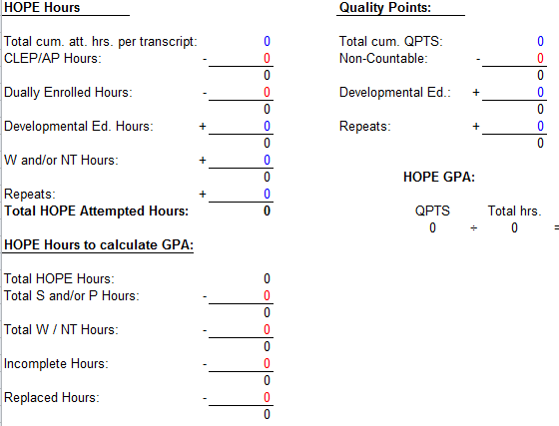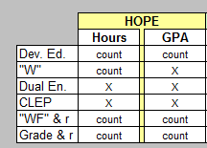

Loss of HOPE & Appeal Process
If you receive notice that you are no longer eligible for your Tennessee Educational Lottery Scholarship funds (TELS HOPE), you may file a written appeal to the Carson-Newman Institutional Review Panel (IRP). You may not file an appeal due to a low GPA.

120 Hour Limitation
A student may be eligible for TELS HOPE for up to 120 hours or 8 full-time semesters, whichever happens later. If the student is enrolled during the summer session, the attempted credit hours must be included in the 120 attempted credit hour limitation if the student first received a TELS award on/after fall 2009, whether or not a TELS award is received during the Summer Session.

Outside Aid

It is important that the Financial Aid Office be notified of any outside assistance as these must be included as part of your award letter, and they may affect your aid eligibility. Outside aid can be in the form of scholarships from churches, organizations, or tuition benefits from employers. Instances where the outside aid is to be used for tuition, and your tuition is paid by C-N resources, your C-N resources will be reduced first before loan assistance.
Outside aid checks that are co-payable to the student and C-N should be endorsed on the back and sent with corresponding details from the provider to the C-N Treasurer’s Office/Student Accounts Office. Documentation should include the student’s name, C-N ID number, and any distribution details. Distribution details indicate whether the check is for one term or two terms and what costs the assistance is eligible to cover. In cases where distribution details are missing, the amount of assistance will be split equally between fall and spring. Please keep copies of all documentation for your records prior to mailing to the following address:
Mail to: Carson-Newman University
Attn: Treasurer’s Office/Student Accounts
1646 Russell Avenue
Jefferson City, TN 37760

Student Employment- Federal Work-Study (FWS)

Students awarded work-study are not guaranteed a job placement. Accepting the work-study award does not commit you to working in the program. Students who wish to be employed must attend the job fair to be placed in a position. Students must also review the Student Employment Handbook prior to working.
If a student has been placed in a position, the student and the department for which the student is working must complete and return the Employee-Employer Hiring Agreement to the Financial Aid Office. The I-9 and W-4 forms must be submitted to the Human Resource Office. Employee-Employer Hiring Agreement form along with the I-9 and W-4 forms must be complete before the student can begin working. The Work-Study Employment Handbook, Employee-Employer Hiring Agreement, and I-9 and W-4 forms are available on the Financial Aid portion of the C-N website under Student Employment.
Students are issued a paycheck on the sixteenth of every month for actual hours worked the previous month. The students’ wages are paid by C-N and in part by the federal government. Eligibility is based upon remaining unmet need.
The number of hours per week that a student is eligible to work is based on the amount of the student’s FWS award. The student and the supervisor will create a schedule that will ensure the student does not earn more than their FWS award amount.
Work-study eligibility amounts are not applied directly to your C-N student account. Students wishing to use their work-study funds to pay a portion of their charges must either personally make a payment or sign over their entire check to the Treasurer’s Office/ Student Accounts. If you choose not to apply work-study funds to your balance, please consider this when determining the amount that you will need to pay for each semester or when making payment plan contracts with our third-party servicer.
*If the sixteenth falls on a weekend, students will be paid on the following business day. Complete employment policies are available in the Student Employment Handbook available online or in print upon request made to the Financial Aid Office.

Federal Direct Stafford Loans

Your Financial Aid Offer may list eligibility for the Subsidized and/or Unsubsidized Direct Stafford Loan program(s). A Stafford loan is a federally guaranteed loan. There is no need for a credit check to receive this loan. You are eligible to participate in the Stafford loan program by completing the FAFSA and meeting other eligibility rules. You should consider loans carefully. Keep in mind that whatever amount you borrow must be paid back with interest. You have the right to decline the loan or request a lower amount.

Loan Limits
The maximum amount you can borrow each year in Direct Subsidized and Unsubsidized Loans depends on your grade level and whether you are a dependent student or an independent student. The following table shows the maximum amount of money you may borrow each academic year in Direct Stafford Loans as well as the aggregate amount you may borrow:
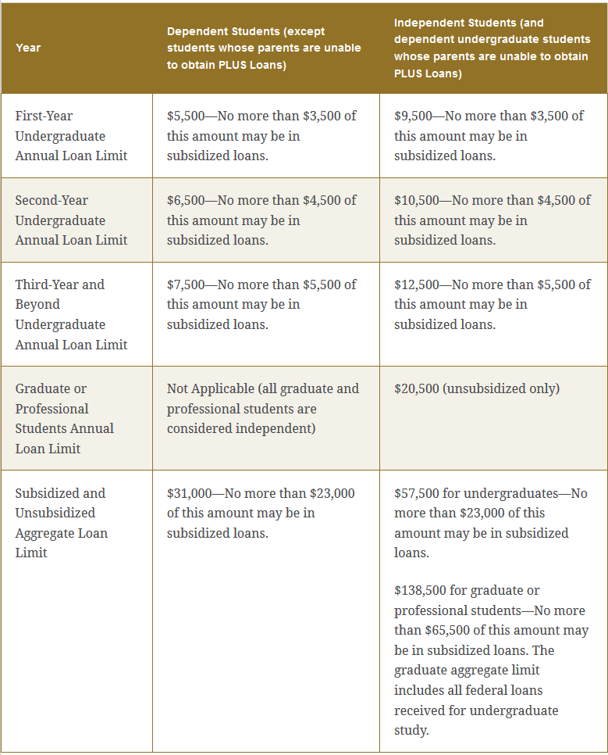
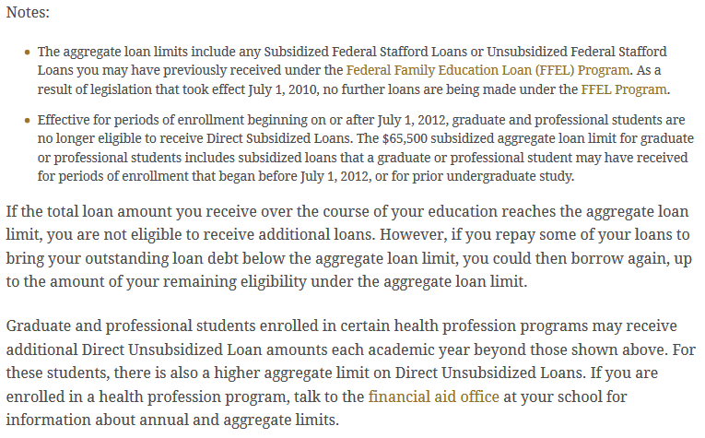
The federal government pays the interest on all Subsidized Stafford loans while you are enrolled in a degree seeking program at least half-time. The Unsubsidized Stafford loan is a non-need-based loan and begins accruing interest when the monies are disbursed to the student. The student is responsible for accrued interest during enrollment periods and the grace period.

Interest Rates
https://studentaid.gov/understand-aid/types/loans/interest-rates -check link for updates
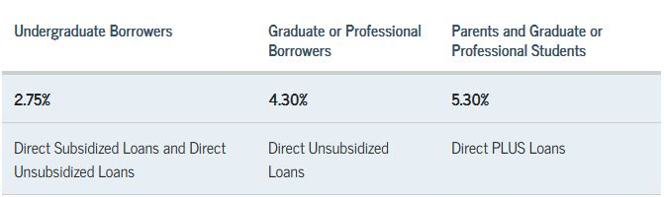

First-Time Borrowers
Students who wish to participate in the Federal Stafford Loan program must accept the loan via a signed Financial Aid Offer or online at MYCN through C-N connect. Students can accept the full amount awarded, or they can request a loan reduction either on a paper award letter or through the C-N email account. Typically, you are awarded the maximum amount of Stafford loans that you are eligible to receive.

Entrance Counseling
Except for parent Direct PLUS Loan borrowers, if you haven't previously received a loan, you must complete Entrance Counseling before your school can make the first disbursement of your loan. This helps you to understand your responsibilities regarding your loan. You may complete this counseling online.

Master Promissory Note (MPN)
To take out a Direct Loan for the first time, you must complete a Master Promissory Note (MPN). You can complete the MPN online at the StudentAid.gov website. The MPN is a legal document in which you promise to repay your loan(s) and any accrued interest and fees to the Department of Education. It also explains the terms and conditions of your loan(s).
To complete an MPN and Entrance Counseling online, you will be required to use your FSA ID login credentials. These are the same login credentials you use to log in to the FAFSA website and file the FAFSA. If you do not have an FSA ID, you may make one from the Department of Education’s student aid website. A parent borrower must also use his/her FSA ID when completing a PLUS MPN.
In most cases, once you've submitted the MPN and it's been accepted, you won't have to fill out a new MPN for future loans you receive. You can borrow additional Direct Loans on a single MPN for up to 10 years. If you are applying for a Direct PLUS for the first time as a graduate/professional student, you'll need to complete and sign a PLUS MPN that is separate from the one that you use for your Direct Subsidized and Unsubsidized Loans.
You will receive a disclosure statement that gives you specific information about any loan that the school plans to disburse under your MPN, including the loan amount, fees, and the expected disbursement dates and amounts.

Continuing/Previous Borrowers
Students who wish to continue participating in the Direct Loan program at C-N must electronically accept loans via your CN Connect Account. All award adjustments are made on the awards online on MYCN or via email from your CN email account. Students can accept the full amount awarded, or they can request a reduction. Typically, you are awarded the maximum amount of Stafford loans that you are eligible to receive. If you borrowed at another school, please log into your FSA account and add Carson-Newman University so we receive your Entrance Counseling and Master Promissory Note as well.

Federal Direct Parent Loan for Undergraduate Students (PLUS)

You will be awarded the maximum amount of Federal Stafford Loan possible for your current student status. Should you require more money for tuition, and you are a dependent undergraduate, your parent may apply for a Parent Loan for Undergraduate Student (PLUS Loan). This is a federal loan in the parent’s name. If your parent is declined, you may become eligible for an additional student Federal Unsubsidized Stafford Loan.
Direct PLUS Loan Borrowers may apply online after June 1st for the fall term at studentloans.gov -more information and additional forms required are available on our website.
PARENTS ARE REQUIRED TO RE-APPLY FOR THE PLUS LOAN EACH YEAR.

Direct Federal Grad PLUS Loans

Federal Grad PLUS Loans are available to graduate students only. A graduate student may apply for the Grad PLUS loan on studentloans.gov. Approval or denial of this loan is based on the student’s credit. Many times, a graduate student’s cost of attendance is covered through other federal loan programs, so any graduate student interested in this loan should contact the Financial Aid Office for eligibility. If a student has reached his or her aggregate limit of Federal Stafford loans, the Grad PLUS loan may be a viable option for additional student loan assistance.

Private Loans

Private loans are consumer-based education loans that are not part of the federal government programs. Private loans are typically more expensive than the federally guaranteed loans and should only be used after all other forms of financial assistance have been exhausted.
If you determine that a private loan is needed, please research your options carefully. Each lender has different fees, interest rates, and repayment options. Most private loans require a co-borrower. Maximum loan amounts vary depending on the amount of their financial assistance you are receiving. Some lenders may defer repayment of principal and interest until a student ceases to be enrolled at least half-time.
Once you have selected a lender, please complete the application on lender website or call a lender to request an application. If the lender approves you, they will send the necessary information to us for us to certify the loan on your C-N account.

Comparison of Federal Loans versus Private Loans

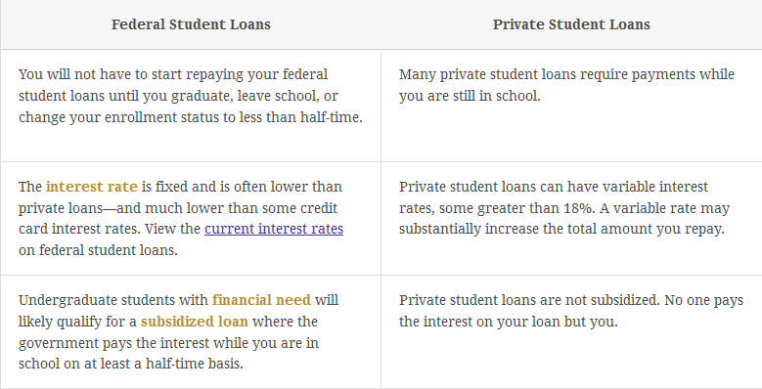
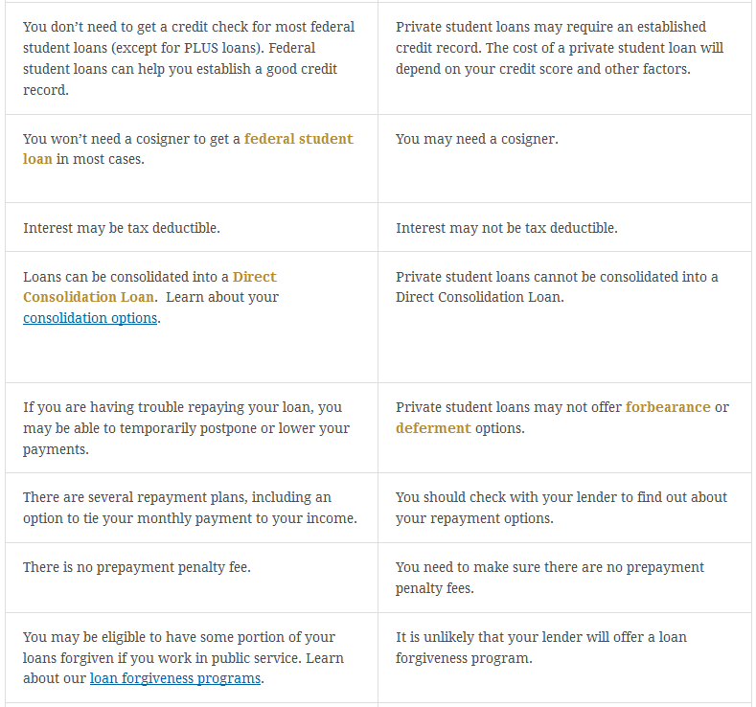

Adjustments and Appeals

Financial Aid Appeal
If a major change occurs in your and/or your family’s financial situation after you receive your Financial Aid Offer, you may contact a Financial Aid Counselor to discuss your circumstances. Additional documentation may then be required should your circumstances warrant an appeal. Once all documentation has been received, the Financial Aid Appeals Committee will review it, and you will be notified by letter the results of your appeal.

FASAP Appeals
If you receive notice that you are no longer eligible for financial assistance due to unsatisfactory academic progress (USAP), you may file a written appeal to the Financial Aid Appeals Committee explaining the extenuating circumstances that led to not meeting the SAP requirements. The Appeals Committee will then determine if you are eligible for extended probation.

TELS HOPE Appeals
If you receive notice that you are no longer eligible for your Tennessee Educational Lottery Scholarship funds (TELS HOPE), you may file a written appeal to the Carson-Newman Institutional Review Panel (IRP). You may not file an appeal due to a low GPA.

Where to Mail Appeals:
Carson-Newman University
Office of Financial Aid
1646 Russell Avenue
Jefferson City, TN 37760

Withdrawal from Carson-Newman

Official Withdrawal
Any student leaving the University before the close of the term must officially withdraw. The student initiates the withdrawal procedures with the Financial Aid Office to discuss changes that will occur in earned aid resulting from withdrawing from C-N. A Financial Aid Counselor will explain how the withdrawal affects your current and future aid. Carson-Newman is required by the Department of Education to determine what portion, if any, of the student’s financial aid is to be returned to the program(s) in which the student participated. Programs that are subject to federal return of funds calculations include the Federal Pell Grant, the Federal Supplemental Education Opportunity Grant (SEOG), Academic Competitiveness Grant (ACG), National SMART Grant, TEACH Grant, Federal Stafford loans, Federal Perkins loans, and PLUS loans. Additionally, your institutional scholarships/funding will be cancelled if you withdraw before incurring 100% of tuition charges. Refer to the tuition refund schedule.

Last Date of Attendance
The Financial Aid Office will use your last date of attendance per academic records during our census period to determine the percentage of federal aid earned based on days of your attendance. Beyond that timeframe, the date of your official notification will be the date used to calculate the percentage of aid you have earned. Unearned aid will be returned to the appropriate program. The Financial Aid Office will provide you with an example of how the earned financial aid is calculated upon request.

Unofficial Withdrawal determinations for Administrative Withdrawal Actions:
If you have a 0.0 GPA at the end of the term, the Registrar’s Office will determine if you have “unofficially withdrawn.” Your unofficial withdrawal date will be the later of either the 50% point in the semester, or a documented date of attendance beyond 50% if available. Students will be responsible for Student Account billings resulting from unearned aid being returned to assistance programs. Refer to last date of attendance determination above.

Loan Exit Counseling Required
If you have federal loans, you are required to complete a loan exit interview upon leaving Carson-Newman. Failure to complete the exit interview may result in your official Carson-Newman transcript being held. Information regarding the exit interview process will be emailed to you and then mailed if not completed from the email request.

Remaining Balances After Withdrawal
Upon withdrawing from Carson-Newman, a student may still owe a balance. If a balance is owed, the student must meet with a Student Accounts Representative. The following schedule is used to determine the amount of tuition refund a student may receive. If you withdraw before being charged 100% of tuition, your University aid will be cancelled since you must be fully charged to earn University funded assistance.

Tuition Refund Schedule for Withdrawal from Fall and Spring Standard Terms*:

During the First week of the semester 90%
During the Second week of the semester 75%
During the Third week of the semester 50%
During the Fourth week of the semester 25%
After four weeks 0%
*In other words, after the fourth week of a semester, no refund will be granted for that semester’s tuition, and you will not lose your University funded aid. Federal aid is earned based upon the student’s days in attendance and has no relation to the tuition refund percentage computed above. For Module Term Attendance Tuition Refund Schedule, consult the University Student Accounts webpage.
Room and board charges are non-refundable after the last day to drop courses. *Summer dates of refunds vary by the term. A summer schedule of dates is available in the Registrar’s Office.

Financial Aid Office Contact Information

The Financial Aid Office is open Monday through Friday from 8:00 a.m. to 4:30 p.m. If you have questions about the financial aid process, items on your award letter, or verification questions, please use the information below to contact us:

Financial Aid Office
Carson-Newman University
1646 Russell Avenue
Jefferson City, TN 37760

Phone Number: (865) 471-3247 or (800) 678-9061
Fax Number: (865) 471-2035
Email: financialaid@cn.edu
*When contacting us, please be sure to have your student identification number in order for us to access your account. Parents and guardians must also know that we are unable to disclose student financial information without the presence and permission of the student to discuss the student’s aid with the parent. The parent must also be on the FAFSA in order to discuss the student’s financial information.

We look forward to serving you!

Glossary of Financial Aid Acronyms

COA – Cost of Attendance to include direct and indirect cost
EFC – Estimated Family Contribution from FAFSA filing
FAFSA – Free Application for Federal Student Aid
FERPA – Family Educational Rights and Privacy Act
FFELP – Federal Family Education Loan Program
GAMS – General Assembly Merit Scholarship
GPA – Grade Point Average on a 4.0 scale
HOPE – TN Education Lottery Award
IRP – Institutional Review Panel to review HOPE appeals
LOA – Federal Leave of Absence
PELL – Federal Pell Grant
PLUS - Parent Loan for Undergraduate Students
SAP – Satisfactory Academic Progress
FSEOG – Federal Supplemental Education Opportunity Grant
SMART – National Science & Mathematics Access to Retain Talent Grant
SUB – Federal Direct Subsidized Loan
TEACH – Teacher Education Assistance for College and Higher Education Grant
TELS – Tennessee Education Lottery Scholarship Program
TSAA – Tennessee Student Assistance Award
UNSUB - Federal Direct Unsubsidized Loan
USAP – Unsatisfactory Academic Progress

